How do I make my Canvas course accessible?

This guide describes how to ensure that Canvas courses can be used by all students, irrespective of a disability, other learning needs, or the method used to access content. Following accessibility guidelines improves usability for everyone, and is a legal requirement.

How do students access content on Canvas?
There are multiple ways of accessing Canvas materials
- Use a keyboard instead of a mouse to navigate
- Use a screen reader to have content read out loud
- Use a screen magnifier to enlarge part or all of a screen
- Use voice commands to navigate
- Use printed versions of pages and documents

Indicate text structure on Canvas pages and in documents
Readers rely on knowledge of the structure of a text to aid understanding. Sighted readers use visual cues such as headings, paragraph breaks and by skim reading for key words; and users of screen readers also need a way of understanding this structure at the outset.

Use heading styles
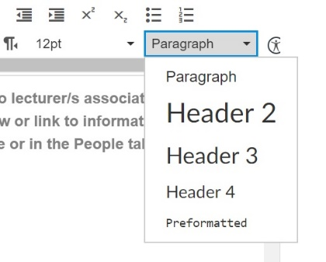
Text-to-speech software cannot recognise section headings or lists marked with visual cues alone, such as text size and underlining. When creating headings, numbered lists and bullet points, always use the ‘heading styles’ and ‘insert’ bullets and numbering options, rather than manually adding visual cues.
Figure 1: Use heading styles in Canvas

In Canvas, these features are built into the tool bar in the text editor (Figure 1). ‘Header 1’ is for the page title, ‘Header 2’ for main sections, and ‘Header 3’ for sub-sections. This enables screen readers to read out the outline of a text and users to browse the content by navigating from heading to heading with a single keystroke. Heading styles, numbered and bulleted lists should be used in all documents. In Microsoft Word and PowerPoint these options are located on the ‘Home’ ribbon.

Use meaningful hyperlinks
Displayed hyperlink text should describe the material that the link points to (e.g. ‘Course handbook’) or its destination. Do not use ‘click here’, or a clunky URL, as this is very ineffective signposting for screen readers.

Use accessible layouts and formatting

Clean layout
Reduce text ‘overload’ by using headings, bullet points, images, short paragraphs and white space to break up the text on the screen appropriately; but balance this with the need for an uncluttered page design overall, as this improves readability and information retention.

Formatting
Accessible formatting enhances readability for all and particularly for those with visual impairments or special learning difficulties. Use:
- Sans serif fonts such as Arial, Verdana, or Calibri
- Minimum font size 12pt or 14pt depending on the font used
- Multiple line spacing, such as 1.5 and left-aligned text
- High colour contrast between text and background
- Avoid italics and underlining.
- Ensure that no meaning is reliant on colour distinctions alone, for those with visual impairments or colour blindness. Always provide an additional cue, such as labelling lines on a graph.

Provide alternative text for images
When embedding an image onto a page, add alternative text (‘Alt tags’) for images, illustrations and charts. This should be a short but descriptive summary of the image, which would be read out by a screen reader. In the text editor in Canvas, there is an option to label an image as ‘decorative’ so that unnecessary ‘alt tag’ descriptions can be avoided.

Use captions and transcriptions for video and audio files
Automated captions are available within Panopto and via YouTube, although these require manual editing to correct errors. External transcription services are available for a fee. Pre-prepared scripts can also be converted to captions by uploading them to Panopto.

Use the accessibility checker in Canvas and in Microsoft Word
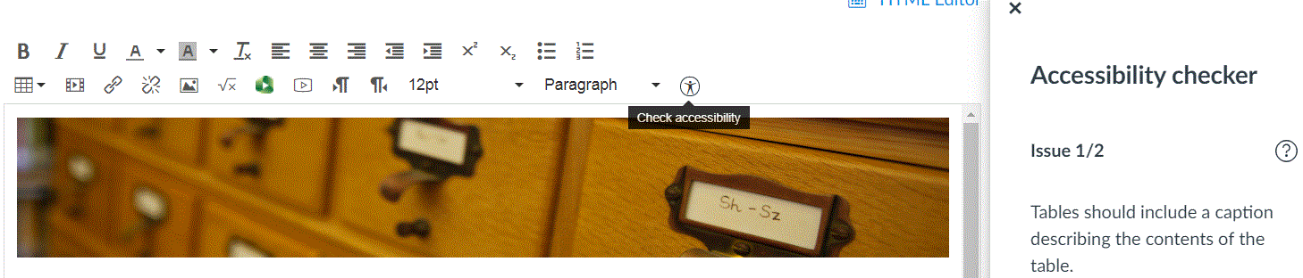
Figure 2: Check accessibility in the text editor
Once you have built a page in Canvas, use the accessibility checker in the text editor (Figure 2) to identify and fix any remaining accessibility issues. In Microsoft Word, ‘Check accessibility’ is located in File> Info> Check document.

Provide documents in accessible formats
Accessible formats include: DOC, tagged PDF, Open Document Format (ODT) and HTML. This improves access for those with a range of disabilities, by providing greater flexibility to adjust the layout, size and font of text, or for conversion to alternative formats.
- When creating PDFs, first check that the original document is accessible (i.e. that the accessibility guidelines described in this document have been followed). Use the ‘Save as’ option rather than ‘Print to PDF’; on the ‘Save as’ screen select PDF, go to ‘Options’ and ensure that ‘Create tagged PDF’ is ticked (it may be called ‘Document structure tags for accessibility’) (for details see WebAim’s guide to accessible pdfs).
- If scanning a document to create a PDF, use Optical Character Recognition (OCR) software to ensure that the text can be read by screen readers and can be copied and pasted.
- Ensure that documents are printer-friendly.
- If a student requests a file in an alternative format, or if you have an untagged or image-based PDF that you would like to share with students, use Sensus Access (hosted by the Bodleian Library) to easily convert files.

